Flow charts

Some tools used during the software development Analysis stage are Decision Tables and Data Flow Diagrams (DFD). These tools are language independent.

Decision Tables are graphical organizations of conditions and their resulting actions - we have seen and used Decision Tables before. Below is another example:

Conditions |  |  |  | Actions
Size (mm) | Shape | Price | Manufacturer
450 | Hexagonal | $45 | DeWitt | Buy
450 | Rectangular | $80 | Thompson | Don’t Buy
450 | Rectangular | $75 | DeWitt | Buy
600 | Hexagonal | $92 | DeWitt | Buy
600 | Rectangular | $130 | DeWitt | Buy
600 | Hexagonal | $93 | Thompson | Buy
600 | Rectangular | $110 | Thompson | Don’t Buy
600 | Octagonal | $112 | Lum | Don’t Buy

Flow Charts are diagrams that describe the flows within a system. The flows could be the flow of control, flow of data, flow of process, or combinations of the three. Focusing on the flow of control, below are the common symbols used in a flow chart, along with an example. There are many applications available to make flow charts; these were made using Word | Insert | Shapes. In Google Docs, there is Google Diagram available to make flow charts.

Start or End of the Flow of Control |  | Indicates where the flow will start and end
Flow |  | Indicate the flow of control.  The symbols are one directional.  The flows in a full diagram should only flow vertically and/or horizontally, and not at angles. This leads to flows having bends.  Flows cannot split, but they can merge.
Decision |  | Indicates when a decision needs to be made.  At this point in the flow, a decision that has a binary result, needs to be make.  Questions are written as succinctly, do not need to be written as normal speack and should fit into the symbol.  There should only be 1 flow into the decision,  and exactly 2 flows out. (Class convention)  The two out flows are labelled Yes/No, or True/False.
Process |  | Indicates a process, or something to be done.  Many flows can enter a process. Only one flow should leave.
Connectors |  | To fit on a page or within specific boundaries, a diagram might need to be split into sections. Connectors are used to show where two sections may fit with each other by allowing flows to enter a connector and continue from another.

Diagrams usually flow from top to bottom or left to right. They should be placed such that the full diagram is centered as much as possible on a page.

Example:

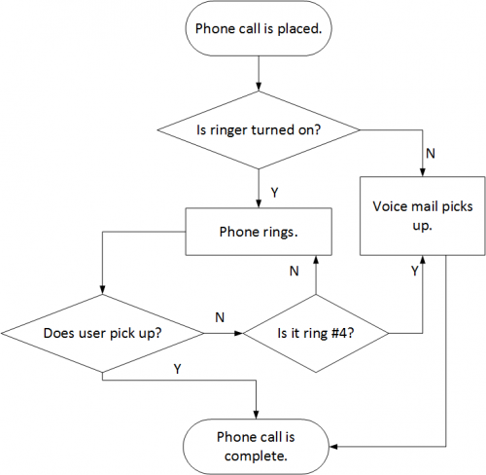

Pseudo Code

A common tool used in the Design stage is Pseudo-code (“false” code). There are no formal rules to writing pseudo-code. Its main purchase is to show the major control structures of the algorithm, and to not hew too closely to any particular language’s syntax (note the examples below do not have the “:” of Python, nor the “;” of Java).
Certain details are described using simplified English. For example, notice in the “Not Bad” version details for how X is coded (from initialization to its maximum value) whereas the “Good” example describes what that X would be used for (to control the flow to process each row of the board).
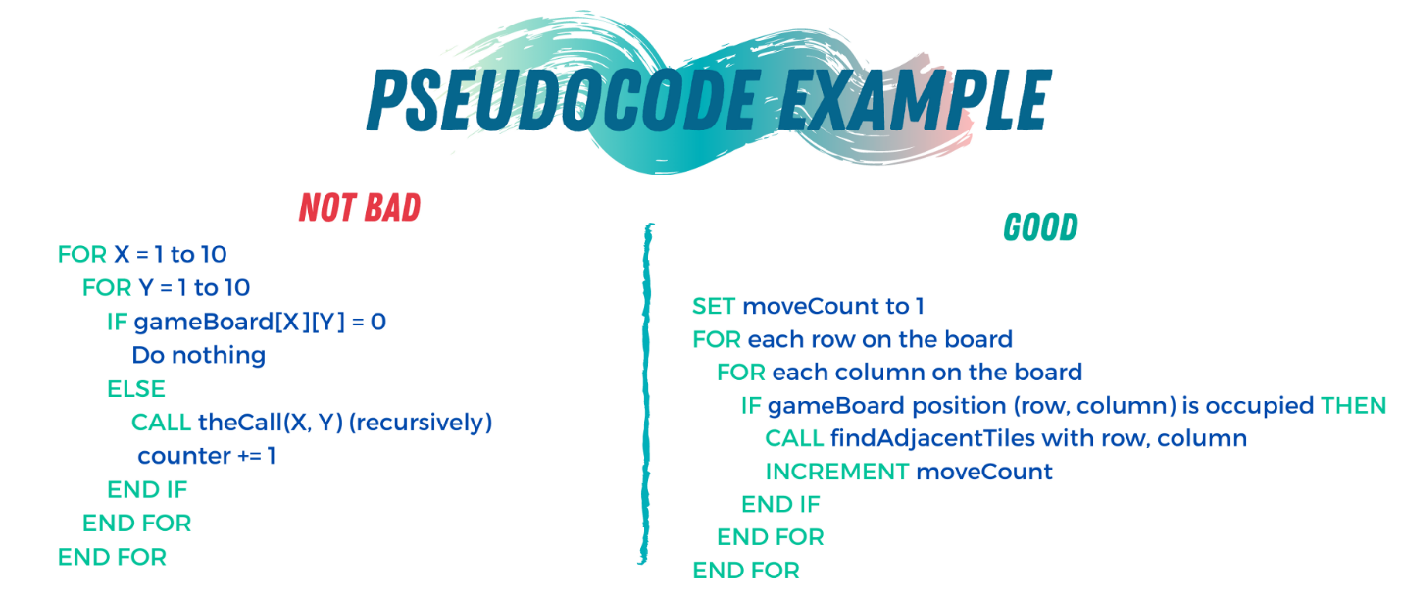
https://towardsdatascience.com/pseudocode-101-an-introduction-to-writing-good-pseudocode-1331cb855be7

In the analysis stage, algorithms are developed that describe the step by step instructions to solve a problem or perform an operation. Pseudo code is a method to help turn the algorithm into code.

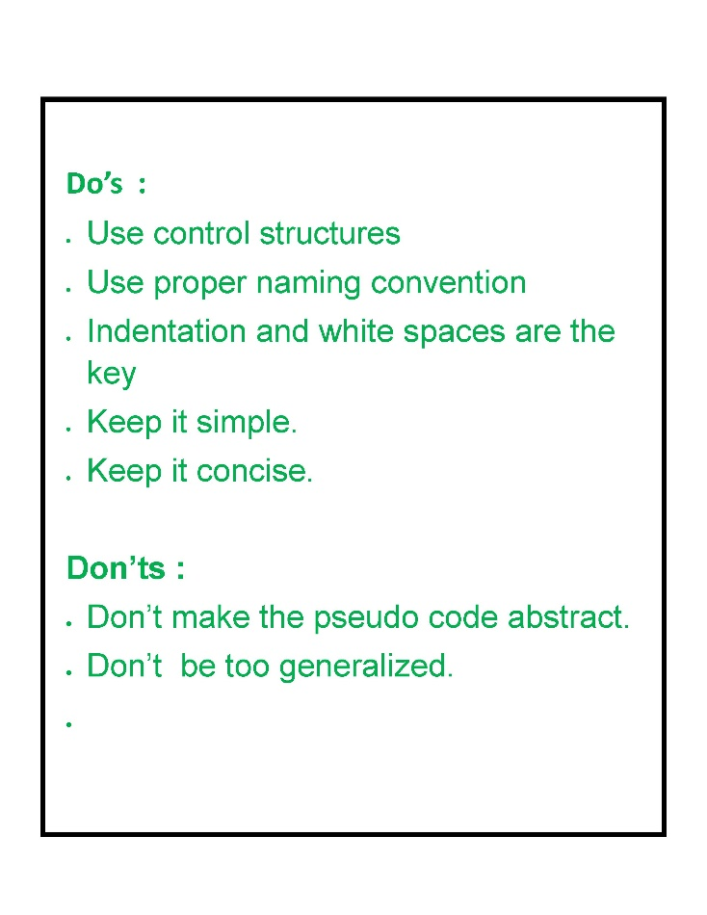

Flow Chart and Pseudo-code Exercises

05.03.01
In Unit “01 Basic Programming/Review”, go to lesson “01_06 Decisions II, III”, document “03.03 Conditional Statements” and exercise 03.03.01 (ie “You Won!”) and draw the flow chart for the program

05.03.02
Develop a program according to the given requirements.

Requirements:
Produce an interactive program that will allow a user to guess for a pre-selected letter.

Software Requirements:
The program will accept a letter from the user.
The program will validate the letter (valid letters are between “a” and “m”, inclusive)
For invalid letters, the program will produce an appropriate message, then allow the user to make another entry.
For valid letters, the program will determine if the guessed letter is too high, too low, or correct.
The evaluation of whether a letter is too high or two low will use the Unicode table.

- Write the pseudo code for:
- the main program
- a subprogram to determine if a letter is valid
- a subprogram to determine if a letter is too high, too low, or correct.

- Optional: From the pseudo code, write the program

